Author: Matthew Eagleman
Date Created: 1/8/2026
2026-1-5 Meeting Minutes
For this meeting we discussed the MVP for our game. While we should be thinking about the story, I think the most important thing to focus on to start making some progress on the game is the actual gameplay. I want to take time to make it feel smooth and satisfying, before the story is even added.

The main gameplay loop will consist of two things:
- Sneaking around and avoiding the father
- Finding new cool items that add abilities and expand access to more parts of the house

We discussed a lot of the specific actions available to the player, along with the inputs and different packages that we will rely on to make them a reality. Please read through the gameplay and mechanics section of the 2026-1-5 Game Design Document to see what we discussed specifically. You can find it here: https://docs.google.com/document/d/1_vRoReakBPD7GWwPdJk2W92yh0bczZ8W1gGMno4Zimk/edit?usp=drive_link

Here are some ideas and such we discussed:
- We decided that it would be best to try and keep all of the user input limited to the keyboard, no mouse.
- Having a treehouse in the backyard as a safe area. We’d have to come up with a reason you can’t just leave the little brother there the whole time though.
- Item idea: hammer and nails? To let you board up passageways so the dad can’t get through. You’d have to get a hold of the crowbar to take them back down.
- The closer you are to the dad, the less noise is needed to get his attention and make him start closing in on you.
- The player could be the one to trigger the power outage, by having the microwave running with a bunch of other stuff plugged into an outlet or something.
- Little brother could carry around another item to give you more room in your inventory
- Event idea, father leaves car running in the garage, you have to navigate down and turn it off to avoid carbon monoxide poisoning.
- Kinda like the previous idea, we could have stuff happening around the house where the dad breaks or messes things up, that you have to go fix.
- You don’t want the dad to get hurt, so you might have to protect him as well.
- You will have to organize your inventory spatially when you pick up new items so things fit, kinda like resident evil VR.
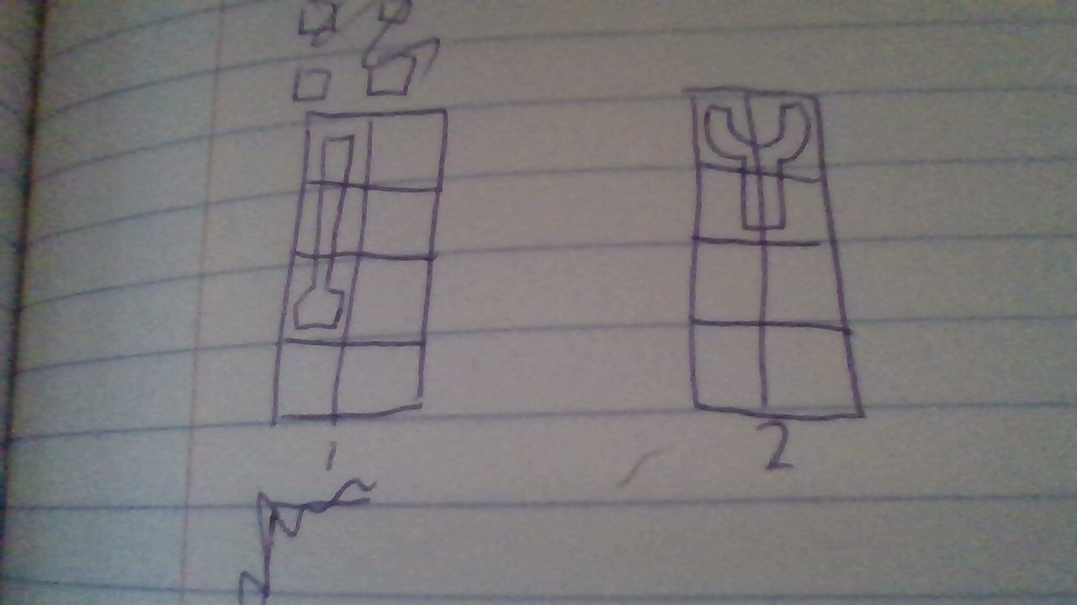
Quick sketch of the inventory system, with two pockets to put items in.
We will have a meeting soon to discuss the programming file architecture. I’ve also begun splitting up the work that needs to be done into tasks, and could use some help coming up with more in depth descriptions of how to know when they are finished, and approximately how long they will take. Here’s where I am at the moment with the architecture (not that far):
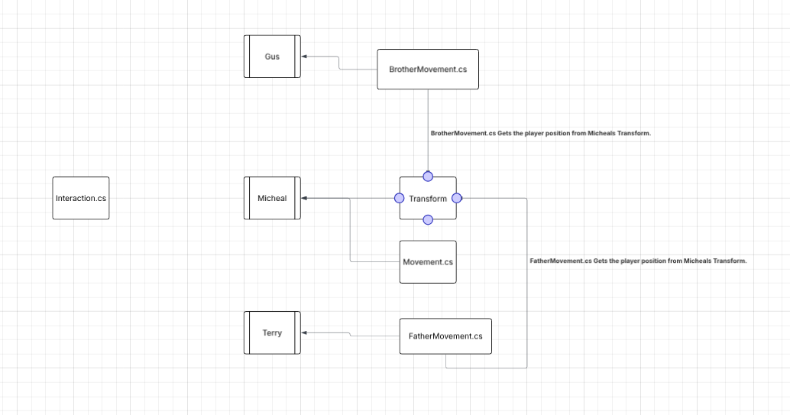

I also assigned some work to a few people to start working on coming up with furniture and room layouts. I sorta forgot what I assigned to who, but it was three rooms each. I didn’t assign anything to anyone that wasn’t there. Here’s an example of what I'm looking for in these room layouts.
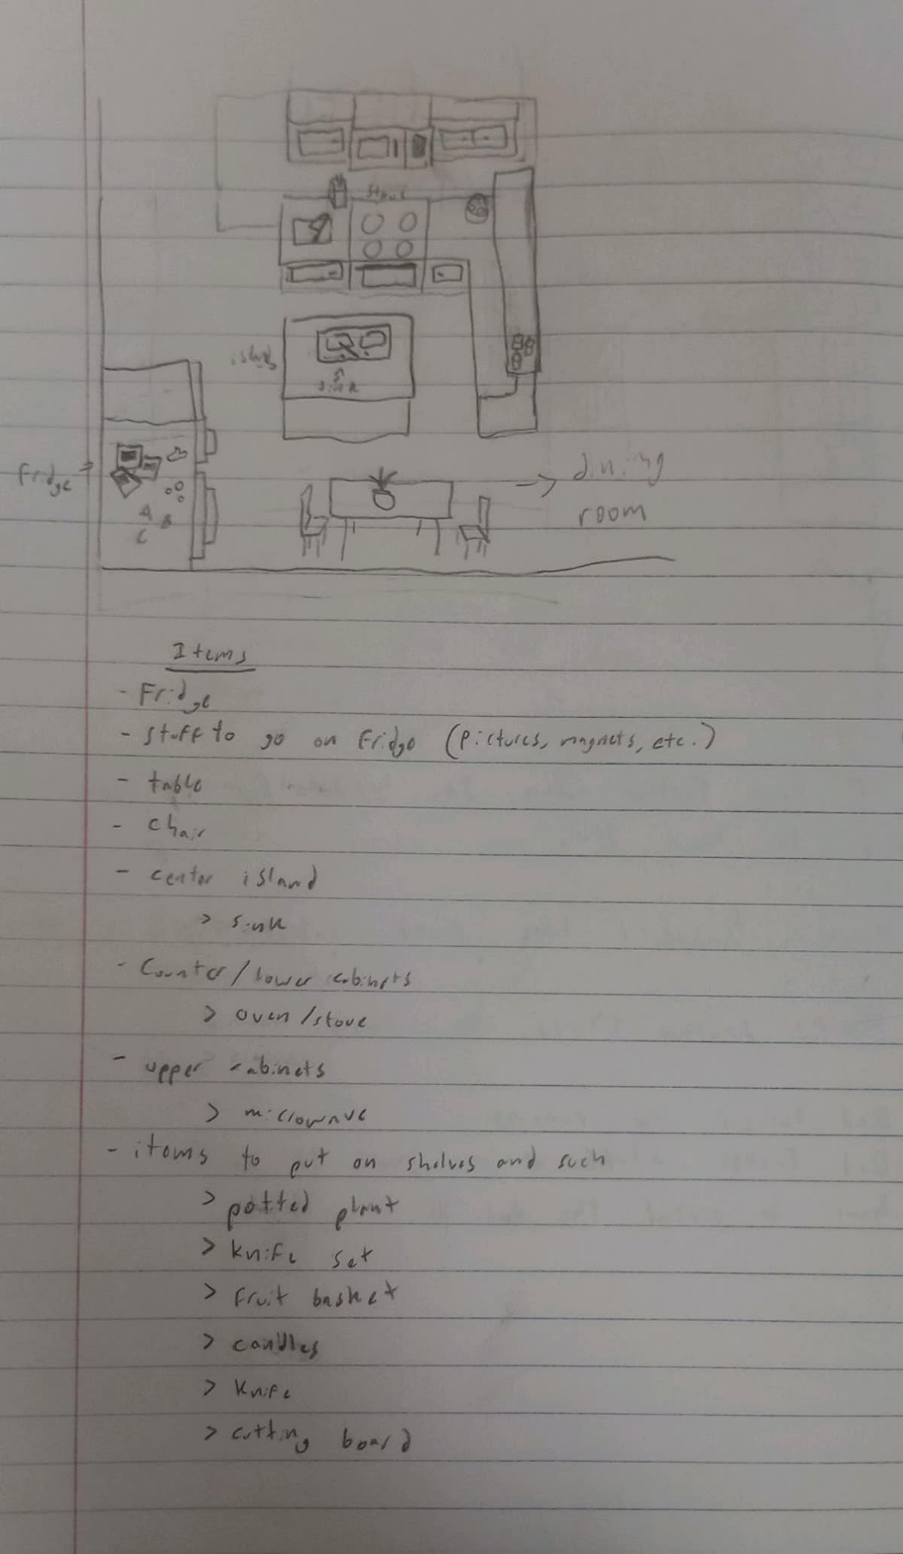

I’d highly recommend watching the video of the meeting if you weren’t there. You can find it here: https://drive.google.com/file/d/1FJq1dvwPJCMpqouO-qEfxbSC9VJVEsAR/view?usp=sharing

